Teachers’ Notes

Listening Task: Making Pizzas

Answer Key | Question Intent
1. C | [inferring speaker’s feelings]
2. B | [extracting specific information]
3. C | [extracting specific information]
4. A | [inferring speaker’s feelings]
5. C | [inferring speaker’s feelings]
6. D | [working out the meaning of some unfamiliar words and phrases]
7. C | [inferring speaker’s feelings]
8. A | [inferring speaker’s feelings]
9. A | [extracting specific information]
10. D | [working out the meaning of some unfamiliar words and phrases]
11.  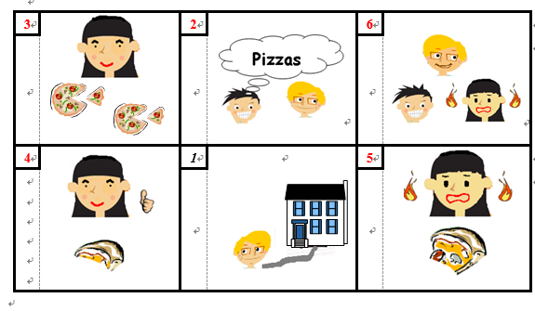 | [understanding narrative texts by forming sensory images of characters, settings and events]  [following the sequence of events in narrative texts]

Transcript

Announcer: | You will listen to a story about Crazy Chris and Sensible Steve making pizzas at home. Listen to the story and answer the questions.  Follow the instructions in the Question-Answer Paper and the recording to complete the task. You will have one minute to read the questions before the recording begins. At the end of the story, you will have two minutes to tidy up your answers.
(A 1-minute pause) (Beep)

Opening: | Hi, I’m Crazy Chris and I’m the craziest boy in Hong Kong. This is crazy!
Narrator: | Crazy Chris has invited Sensible Steve over to his house.
Crazy Chris: | Dad, when is Steve going to arrive? I want to have some fun.
Chris’s Dad: | He’ll be here soon, Chris. What are you two doing today?
Crazy Chris: | Well, I thought we can eat pizza together. (Singing ‘Pizza. Yummy, yummy, yummy. I love pizza.’)
Narrator: | The doorbell rang. Guess who it was. That’s right. Sensible Steve.
Crazy Chris: | Hi, Steve. It’s good to see you.
Sensible Steve: | Hey, Chris. What are we going to do today? Nothing too crazy, I hope.
Crazy Chris: | (excited) I thought we can make pizza!
Sensible Steve: | I love pizza, but only sensible pizza.
Crazy Chris: | Let’s get cooking!
Carol: | Chris, you are always doing crazy things. I can’t wait to see your pizza.
Narrator: | Chris and Steve decided they would both make a pizza and let Carol judge whose was the tastiest.
Carol: | Okay, boys, remember I’ll be eating the pizzas and deciding the winner. So make them as tasty as you can.
Announcer: | Now, answer Questions 1 to 2.
(A 15-second pause) (Beep)

Narrator: | Crazy Chris and Sensible Steve started cooking their pizzas. Sensible Steve put lots of vegetables and healthy ingredients on his pizza.
Carol: | Wow, they smell great, boys. What did you put on yours, Chris?
Crazy Chris: | I’m not telling you, Carol.
Carol: | (worried) Chris, what did you put on your pizza? Nothing horrible, I hope.
Crazy Chris: | Don’t worry, Carol. Chill out a bit.
Announcer: | Now, answer Questions 3 and 4.
(A 15-second pause) (Beep)

Narrator: | The pizzas were cooked. Chris and Steve put their pizzas on the table in front of Carol to try.
Carol: | I’m going to try yours first, Sensible Steve.
Sensible Steve: | (excited) Well Carol, mine was the sensible, healthy pizza. So you’ll find lots of things that are good for you on my pizza.
Carol: | Okay, here it goes.
Narrator: | Carol took an enormous bite out of the pizza.
Carol: | That’s delicious, Steve.
Crazy Chris: | That’s en......nough!
Carol: | Right, then Chris. Remind me, what’s on your pizza again?
Crazy Chris: | No way Carol. Just be brave and try it.
Narrator: | What could Chris have put on the pizza? Will Carol like it? Let’s find out.
Carol: | Okay, Chris, here I go.
Narrator: | Carol took a huge bite from the pizza Chris had made.
Carol: | (screaming angrily) Chris! What did you put on the pizza? It’s… It’s burning my mouth!
Crazy Chris: | I might have put a few chillies on there.
Carol: | Chillies? How many?
Crazy Chris: | Hm… about one hundred and ten. Oh! And lots of yummy wasabi! (laughing)
Narrator: | Everyone was laughing.
Carol: | Chris, you’re crazy.
Narrator: | Carol’s mouth was totally burning up! Burn! Burn! Ha, ha, ha, ha…
Announcer: | This is the end of the story. You now have two minutes to answer Questions 5 to 11 and to tidy up your answers for the whole task.
(A 2-minute pause) (Beep)

Announcer: | This is the end of the recording.

